2013-0642
AAG

REPORT OF THE PLANNING AND DEVELOPMENT DEPARTMENT FOR

APPLICATION FOR REZONING ORDINANCE 2013-0642 TO

PLANNED UNIT DEVELOPMENT

OCTOBER 10, 2013

The Planning and Development Department hereby forwards to the Planning Commission, Land Use and Zoning Committee and City Council its comments and recommendation regarding Application for Rezoning Ordinance 2013-0642 to Planned Unit Development.

Location: Southeast quadrant of San Pablo Road and J Turner Butler Boulevard, Between Marina San Pablo Place and Dixie Landing Drive

Real Estate Numbers: 181772 0025 and 181772 0000

Current Zoning District: Commercial Office (CO)

Proposed Zoning District: Planned Unit Development (PUD)

Current Land Use Category: Residential Professional Institutional (RPI)

Proposed Land Use Category: Community General Commercial (CGC)

Planning District: Southeast, District 3

City Council District: The Honorable Bill Gulliford, District 13

Applicant/Agent: Greg S. Kupperman
Green & Kupperman, Inc.
200 First Street, Suite B
Neptune Beach, Florida 32266

Owner: Walter D. Dickinson
1 Independent Drive
Jacksonville, Florida 32202

Staff Recommendation: APPROVE WITH CONDITIONS

GENERAL INFORMATION

Application for Planned Unit Development 2013-0642 seeks to rezone approximately 1.51± acres of land from CO to PUD. The rezoning to PUD is being sought for the purpose of developing a hotel not to exceed 120 rooms and not to exceed a height of 105 feet; including one limited food service café and meeting rooms for hotel guests. There will be a maximum of 85,000 square feet of non-residential floor area, with total land coverage of 22, 869+/- square feet. The property is currently undeveloped, 721 feet deep at the southern property line, 622 feet deep at the northern property line, by 100 feet wide. A building setback from the east property line will follow a formula of 1.48 feet for every 1 foot of building height up to 105 feet in height. Retail and shopping uses supporting the hotel use will be limited to the industry standards for the hotel of which it is a part. A rooftop pool with cabana facilities and fitness center will also be included. PUD (2008-653-E) approved a hotel development with strict setback requirements on the site directly south from the subject property, across Dixie Landing Drive, a private right-of-way.

How does the proposed PUD differ from the usual application of the Zoning Code? (Applicant response)
This PUD District will differ from the conventional zoning district by excluding the less desirable uses found in the conventional CCG-1 District. This PUD will be specifically limited to hotel and supporting retail and service uses as provided herein. Excluding the less desirable uses will make this PUD District more compatible with existing and proposed surrounding uses. The PUD District also provides a site plan and is specific as to other design criteria unique to the subject property like access points for ingress and egress.

There is a companion Application for Small Scale Land Use Amendment to the Future Land Use Map Series of the 2030 Comprehensive Plan, Ordinance 2013-0642 (Application 2013C-021) requesting to change the functional land use category of the subject property from Residential Professional Institutional (RPI) to Community General Commercial (CGC). The Planning and Development Department has submitted its report on the companion Small-Scale Land Use Amendment 2013C-021 and recommends that the same be approved.

CRITERIA FOR REVIEW

Pursuant to the provisions of Section 656.125 of the Zoning Code, the Planning and Development Department, Planning Commission and City Council (including the appropriate committee) shall evaluate and consider the following criteria of an application for rezoning to Planned Unit Development.

(1) Is the proposed zoning district consistent with the 2030 Comprehensive Plan?

Yes. The Planning and Development Department finds that the subject property is located in the Residential Professional Institutional (RPI) functional land use category as defined by the Future Land Use Map series (FLUMs) contained within the Future Land Use Element (FLUE) adopted as part of the 2030 Comprehensive Plan. However, there is a companion Application for Small-Scale Land Use Amendment to the Future Land Use Map Series 2013C-021 (Ordinance 2013-641) that seeks to amend the portion of the site that is within the RPI land use category to Community General Commercial (CGC). Staff is recommending that Application for Small-Scale Land Use Amendment to the Future Land use Map Series 2013C-021 be approved. Therefore, the proposed rezoning is consistent with the FLUMs adopted as part of the 2030 Comprehensive Plan pursuant to Chapter 650 Comprehensive planning for future development of the Ordinance Code. A description of the category is noted below.

The Community/General Commercial (CGC) land use designation includes outlets and establishments that offer a wide range of goods and services including general merchandise, apparel, food and related items. General commercial uses include business and professional offices, financial institutions, highway commercial, mobile home/motor home rental and sales, off-street parking lots and garages, and boat storage and sales, among other similar types of commercial developments.

(2) Does the proposed rezoning further the goals, objectives and policies of the 2030 Comprehensive Plan?

Yes. The evaluation of the goals, objectives and policies of the Comprehensive Plan can be found later in this report.

(3) Does the proposed rezoning conflict with any portion of the City’s land use Regulations?

No. The written description and the site plan of the intended plan of development meet all portions of the City’s land use regulations and further their intent by providing specific development standards.

Furthermore, pursuant to the provisions of Section 656.341(d) of the Zoning Code, the Planning and Development Department, Planning Commission and City Council (including the appropriate committee) shall evaluate and consider the following criteria for rezoning to Planned Unit Development district as follows:

(1) Consistency with the 2030 Comprehensive Plan

In accordance with Section 656.129 Advisory recommendation on amendment of Zoning Code or rezoning of land of the Zoning Code, the subject property is within the following functional land use categories as identified in the Future Land Use Map series (FLUMs): Residential Professional Institutional (RPI). There is a companion Application for Small-Scale Land Use Amendment to the Future Land use Map Series 2013C-021 (Ordinance 2013-0641) that seeks to amend the portion of land that is within the RPI land use category to CGC. This proposed rezoning to Planned Unit Development is consistent with the 2030 Comprehensive Plan including the following goals, objectives and policies:

FLUE Objective 1.1 Ensure that the type, rate and distribution of growth in the City results in compact and compatible land use patterns, an increasingly efficient urban service delivery system and discourages the proliferation of urban sprawl through implementation of regulatory programs, intergovernmental coordination mechanisms, and public/private coordination.

FLUE Policy 1.1.22 Future development orders, development permits and plan amendments shall maintain compact and compatible land use patterns, maintain an increasingly efficient urban service delivery system and discourage urban sprawl as described in the Development Areas and the Plan Category Descriptions of the Operative Provisions.

FLUE Objective 3.2 Continue to promote and sustain the viability of existing and emerging commercial and industrial areas in order to achieve an integrated land use fabric which will offer a full range of employment, shopping, and leisure opportunities to support the City's residential areas.

FLUE Policy 3.2.7 The City shall implement the locational criteria of this element for commercial and industrial uses consistent with the character of the areas served, availability of public facilities, and market demands.

FLUE Policy 3.2.14 The City shall permit consideration of commercial uses, including hotels
and motels, at intensities at or above the neighborhood serving commercial scale at locations with direct road access to interstate connectors and within the commercial node of an interstate interchanges. Such development within the commercial node must be pursuant to a Planned Unit Development (PUD) zoning district, and subject to all other applicable local, state and federal regulations.

FLUE Objective 6.3 The City shall accommodate growth in Jacksonville by encouraging and facilitating new development and redevelopment on vacant, bypassed and underutilized land within areas that already have infrastructure, utilities, and public facilities, while addressing the needs of City residents.

(2) Consistency with the Concurrency and Mobility Management System

Pursuant to the provisions of Chapter 655 Concurrency and Mobility Management System of the Ordinance Code, the development will be required to comply with all appropriate requirements of the Concurrency and Mobility Management System Office (CMSO) prior to development approvals. Development Agreement # 71789 reserves 70,000 enclosed square feet of ITE 710: General Office, which may also be used for a bank with four teller lanes. The applicant will be required to do a trip generation conversion if a hotel is to be built.

(3) Allocation of residential land use

This proposed Planned Unit Development does not intend to utilize lands for residential use.

(4) Internal compatibility

This proposed PUD is consistent with the internal compatibility factors with specific reference to the following:

The existence or absence of, and the location of open spaces, plazas, recreational areas and common areas:
No open spaces or common areas are proposed.

The use of existing and proposed landscaping:
The project will be required to meet the minimal standards set forth in Section 656, Part 12.

The treatment of pedestrian ways:
The project will contain an internal pedestrian system that meets the 2030 Comprehensive Plan.

Traffic and circulation patterns:
The property will be accessed through one point of access on Marina San Pablo Place, a private road that permits access to adjacent commercial parcels. Internal traffic circulation consists of a one-way loop allowing for traffic to flow in a counter clock wise manner on the site, and through a first level parking area under the hotel building. There is sufficient room for emergency access and shuttle bus vehicles to navigate onsite and alternate routes to allow for vehicles to make a turn before circulating to the rear of the property.

The use and variety of building setback lines, separations, and buffering:
Minimum lot size, lot width, maximum lot coverage and yard requirements will be consistent with the CCG-1 District. If the hotel building is built to a maximum height of 105 feet, a 155 feet setback from the easterly property line shall be enforced. A similar setback is built into the commercial hotel PUD (2008-653-E) directly to the south, across Dixie Landing Drive.

Signage:
Signage will follow the requirements found within the CCG-1 Zoning District except for the following:

(1) One wall identification sign along the north and south (broad side) and west (narrow side of the hotel) facades, not to exceed 5 percent of each façade, not to exceed 200 square feet on the north façade, 500 square feet on the west façade, and 200 square feet on the south façade.

(2) One freestanding identifying sign not to exceed 150 square feet and not to exceed 10 feet in height may be constructed as part of the landscape entrance along Marina San Pablo Place.

(3) Traffic directional signals and directional signs, not to exceed 4 square feet will be permitted.

(5) External Compatibility

Based on the written description of the intended plan of development and site plan, the Planning and Development Department finds that external compatibility is achieved by the following:

Those areas of the proposed PUD located on or near its perimeter and the conditions and limitations thereon:
Setback requirements found within the requirements of the CCG-1 Zoning District shall apply to this development.

The type, number and location of surrounding external uses: The proposed development is located north of a private right of way, Dixie Landing Drive, which serves single-family homes along the Intracoastal. Marina San Pablo luxury condominiums are located east of the property on the waterfront. There is an undeveloped property to the north, which is subject to Land Use Amendment 2013C-017 (Ordinance 2013-633) and PUD Rezoning 2013-634 for a commercial hotel/retail development. The property has direct access to Marina San Pablo Place

The Comprehensive Plan and existing zoning on surrounding lands: The adjacent uses, zoning and land use categories are as follows:

Adjacent Property | Land Use Category | Zoning District | Current Use(s)
North | RPI → CGC 2013C-017 | CRO → PUD (2013-632) | Undeveloped
East | MDR | PUD (2001-818) | Condo multi-family
South | CGC | RLD-60  PUD (2008-653) | Single-family  Undeveloped/hotel approved
West | CGC | CO | San Pablo Road

Any other factor deemed relevant to the privacy, safety, preservation, protection or welfare of lands surrounding the proposed PUD which includes any existing or planned use of such lands:

Noise Abatement: All exterior speakers or audio transmission devises used on or about the site will be situated and operated at reasonable volumes. No exterior speakers will be allowed within 200 feet of the easterly boundary. Ambient noise levels will be capped at 55 decibels.

Illumination: Quality of lighting shall be controlled to minimize unreasonable interference of impact to surrounding residential zones. No exterior lights shall be directed towards the residential parcels along Dixie Landing Drive.

Outside Entertainment: Outside entertainment shall be prohibited.

(6) Intensity of Development

The proposed development is consistent with the CGC functional land use category and is a single-use, commercial development, which is not to exceed 120 hotel suites. The PUD is appropriate at this location with specific reference to the following:

The amount and type of protection provided for the safety, habitability and privacy of land uses both internal and external to the proposed PUD:
Should the owner of the adjoining property (RE# 181771-0000) to the north agree to connectivity between the two sites, the PUD will allow for a cross access connection.

The availability and location of utility services and public facilities and services:
The site is served by city sewer and water.

The access to and suitability of transportation arteries within the proposed PUD and existing external transportation system arteries:
A transportation impact analysis by the Transportation Planning Division in their memorandum dated September 10, 2013 produced the following comments:
“San Pablo Road is the directly accessed functionally classified roadway to be impacted by this project. San Pablo has maximum daily service volume of 39,800 vpd and a 2012 daily traffic volume of 4,974 vpd and is currently operating at an acceptable LOS C. This road segment currently has sufficient capacity to accommodate the expected traffic volumes proposed by this development.”

(7) Usable open spaces plazas, recreation areas.

The project is not required to provide any active recreation areas.

(8) Impact on wetlands

Surveying of a 1995 Geographical Information Systems shape file did not identify any wetlands on-site. Any development impacting wetlands will be permitted pursuant to local, state and federal permitting requirements.

(9) Listed species regulations

No wildlife survey was required as the project is less than the 50-acre threshold.

(10) Off-street parking including loading and unloading areas.

Parking will be provided consistent with a minimum of .9 spaces for each 1 guest room, less than the industry standard. Ancillary uses on site will be designed and scaled for hotel guests only, creating no additional parking. The hotel is intended to be used by patients and their families of the Mayo Clinic. Guests will have the opportunity to use shuttle and taxi services.
(11) Sidewalks, trails, and bikeways

The project will contain an internal pedestrian system that meets the 2030 Comprehensive Plan. There will also be external sidewalks as required.

SUPPLEMENTAL INFORMATION

Upon visual inspection of the subject property on September 26, 2013, the required Notice of Public Hearing sign was posted.

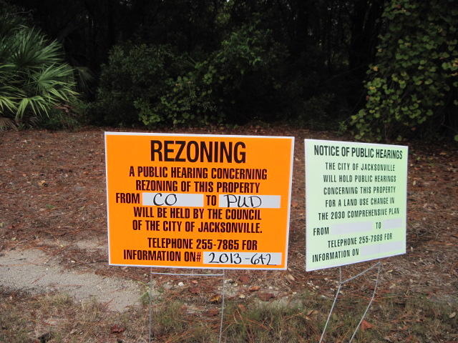

Source: Planning and Development Department
Date: September 26, 2013

RECOMMENDATION

Based on the foregoing, it is the recommendation of the Planning and Development Department that Application for Rezoning 2013-0642 be APPROVED with the following conditions:

1) The subject property is legally described in the original legal description dated July 16, 2013.

2) The subject property shall be developed in accordance with the revised written description dated September 25, 2013.

3) The subject property shall be developed in accordance with the revised site plan dated September 30, 2013.

4) The subject property shall be developed in accordance with the Development Services Division or as otherwise approved by the Planning and Development Department.

5) A 6 foot high fence 100% opaque fence shall be installed along the south property line where it abuts the right-of-way of Dixie Landing Drive.

6) All sag lenses, drop lenses and convex lenses shall be prohibited. Illumination levels at all property lines shall not exceed one-half (0.5) foot candles (f.c.) when the building or parking areas are located adjacent to residential areas, and shall not exceed one (1.0) f.c. when abutting other non-residential properties. All lighting lamp sources within parking and pedestrian areas shall be metal halide or compact fluorescent. The maximum light pole height in all parking areas should not exceed twenty five feet (25’- 0”). An exterior lighting design plan for each project, including a photometrics plan and pole and fixtures schedules shall be submitted at the time of Verification of Substantial Compliance for review and approval by the Planning and Development Department.

7) The wall sign on the south side of the building shall be non-illuminated.

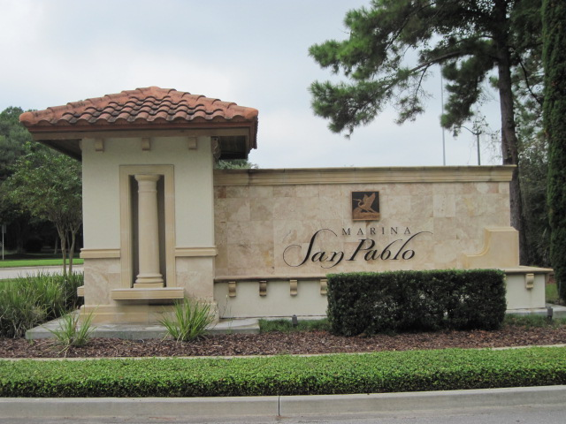
Entry sign along San Pablo Road to Marina San Pablo private drive.

Source: Planning and Development Department
Date: September 26, 2013

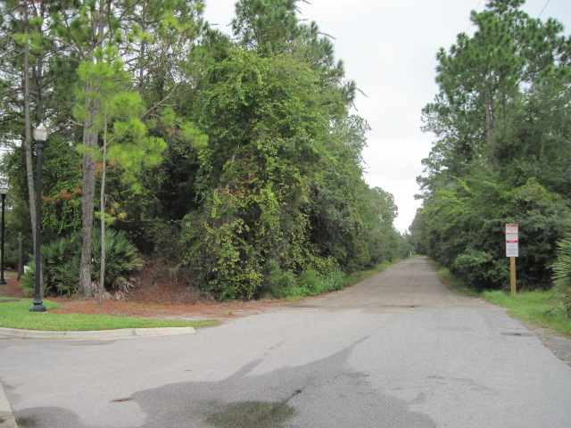
Private Dixie Landing Drive dirt road (view from San Pablo and
Marina San Pablo Place intersection.)

Source: Planning and Development Department
Date: September 26, 2013

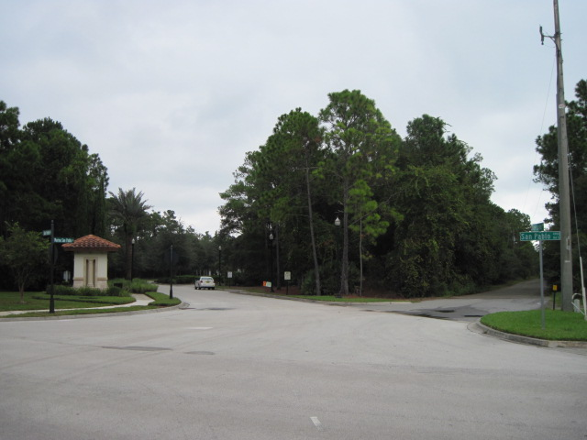
Dixie Landing Drive and Marina San Pablo Place intersection.

Source: Planning and Development Department
Date: September 26, 2013

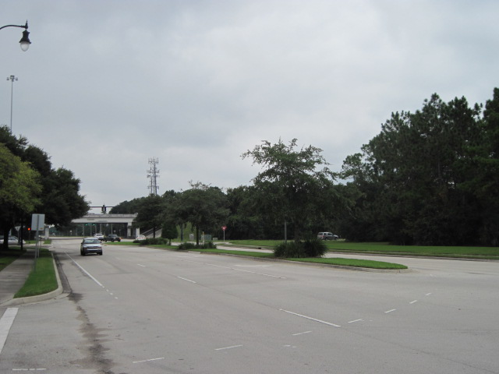
View looking south toward J.T. Butler Boulevard and onramp
(from Allstate driveway across San Pablo Road)

Source: Planning and Development Department
Date: September 26, 2013

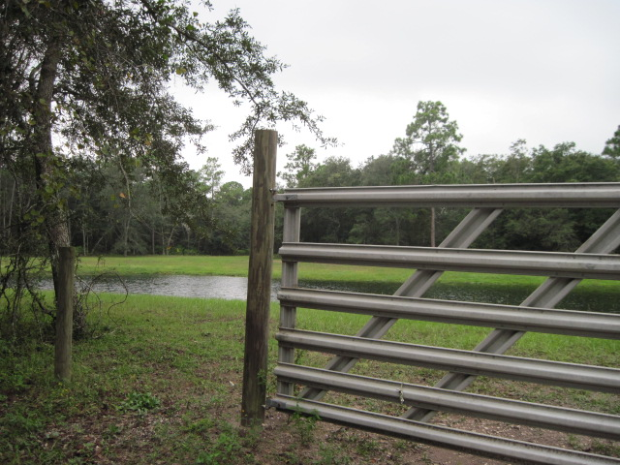
Retention pond on PUD (2008-563-E) east property line.
View from Dixie Landing Drive.

Source: Planning and Development Department
Date: September 26, 2013

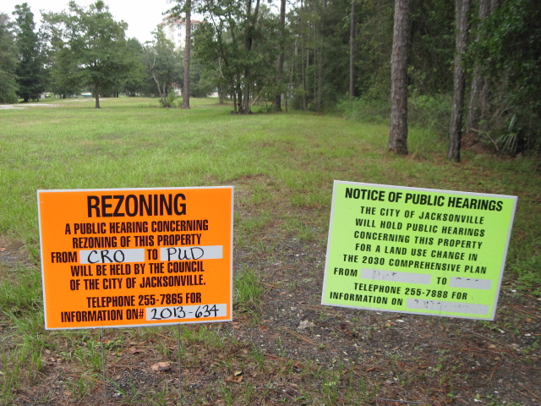
Undeveloped property to the north.

Source: Planning and Development Department
Date: September 26, 2013

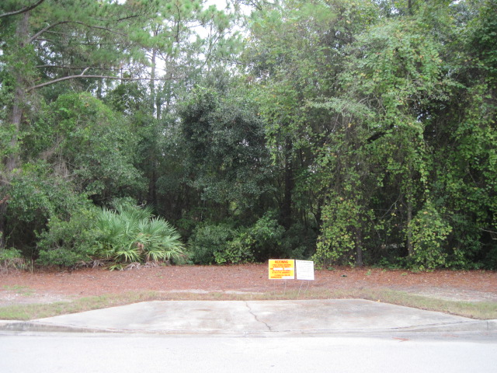
Existing curb cut out on the subject property.

Source: Planning and Development Department
Date: September 26, 2013

